Andrei Gaille B. Sioson
S2025101980
10/10/26

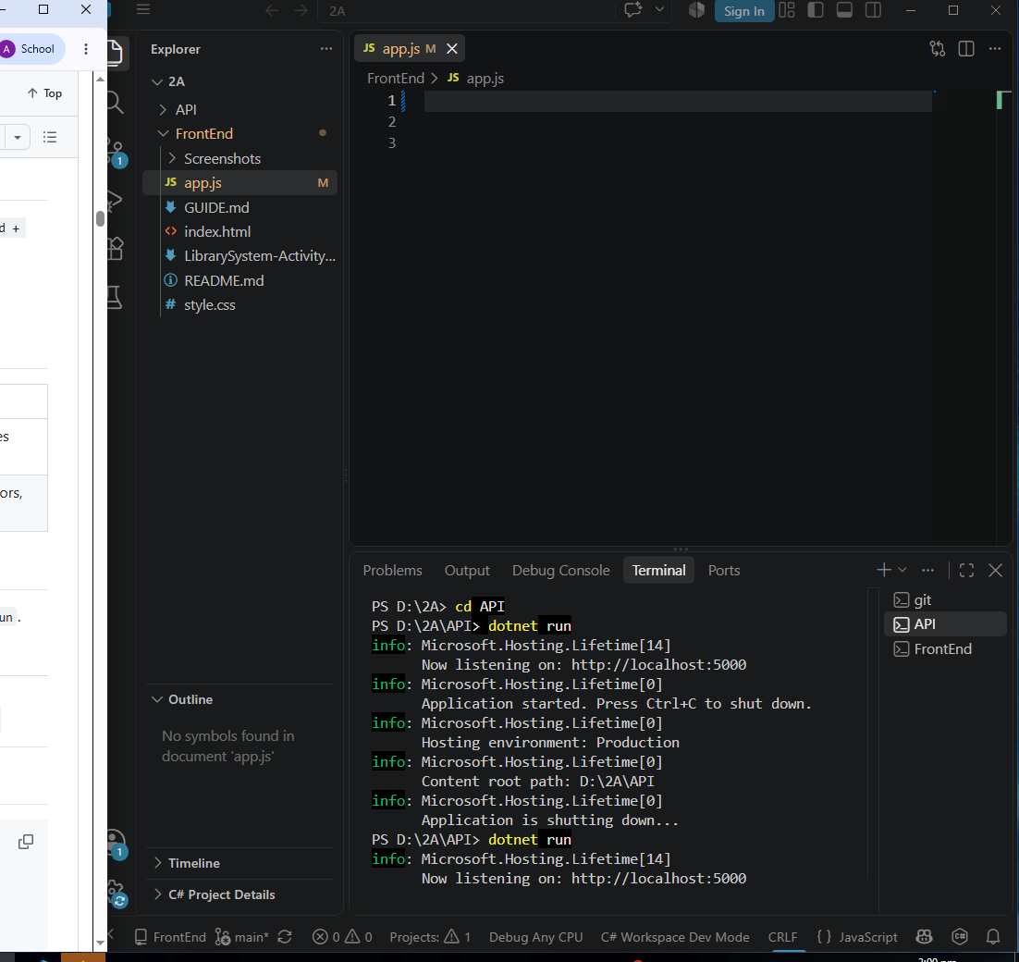
setup-01-api-running SCREENSHOT

Setup-02-api-books-json SCREENSHOT
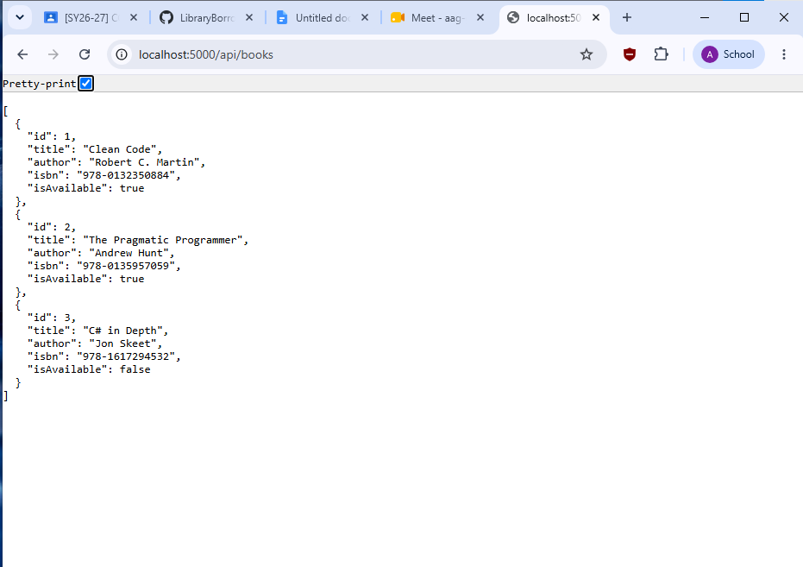

Part-01-settings-apifetch SCREENSHOT 1
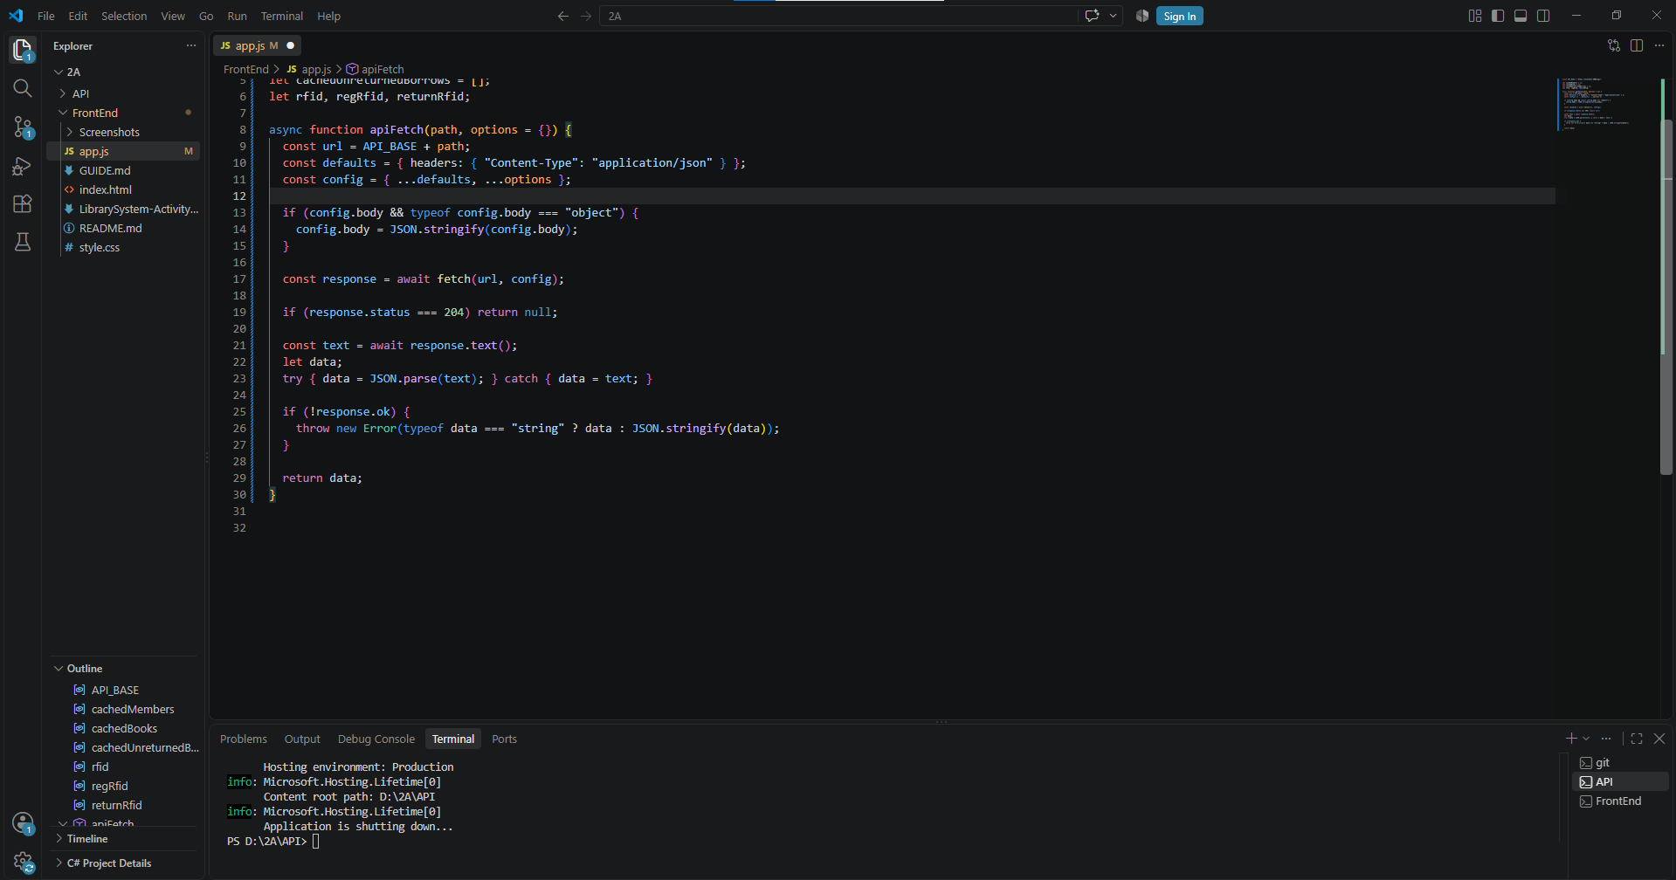

Part-02-showtoast SCREENSHOT 2
Function
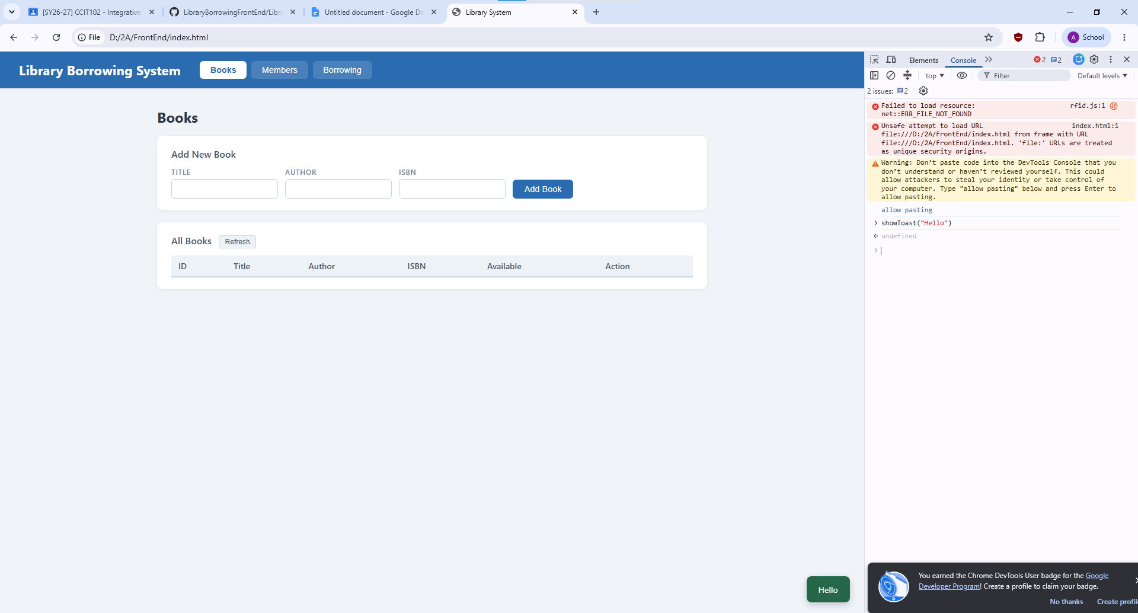
Code
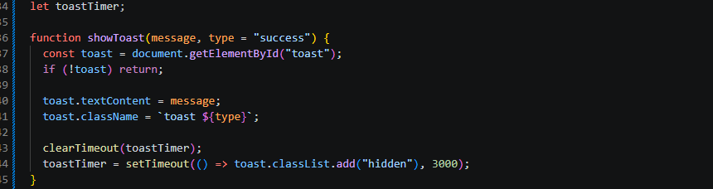

Part-03-caches SCREENSHOT 3
Function
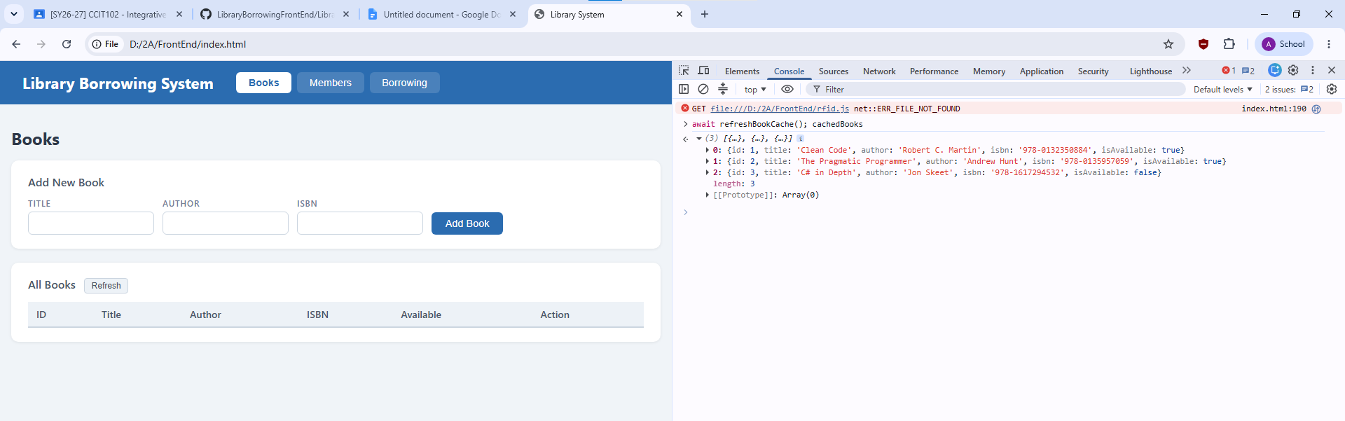
Code
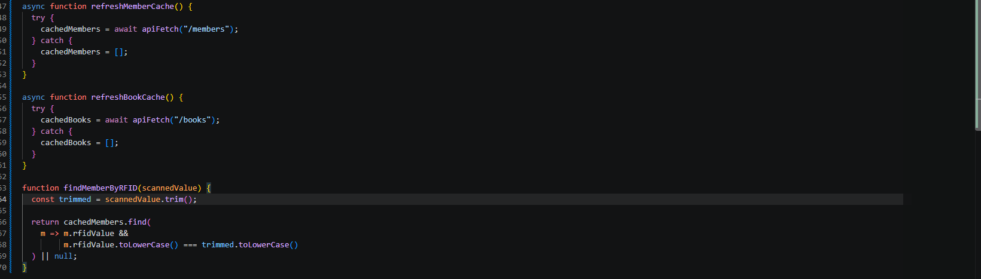

Part-04-tabs-refresh SCREENSHOT 4
Code
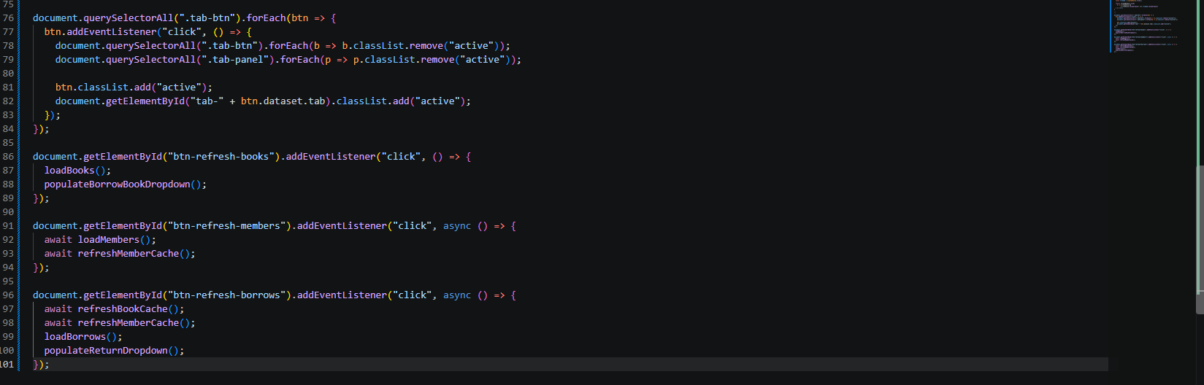
Function
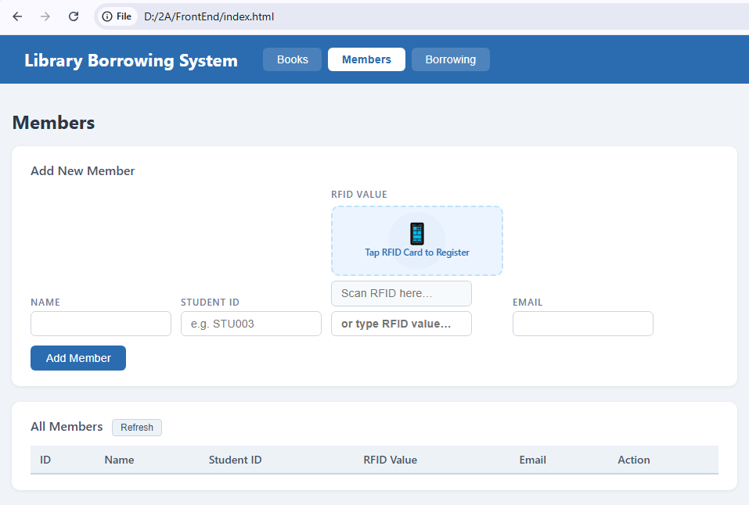

Part-05-loadbooks SCREENSHOT 5
Code
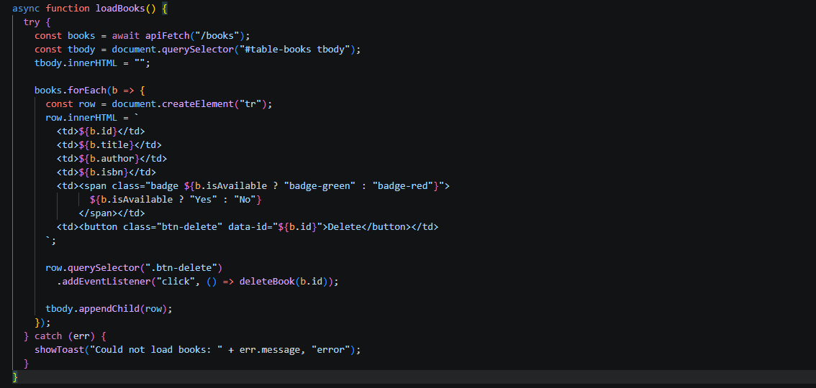

Part-06-deletebook SCREENSHOT 6
Code
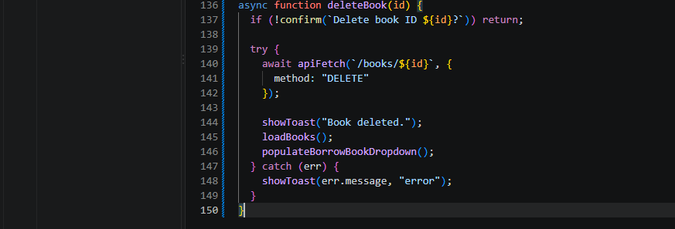

Part-07-addbook SCREENSHOT 7
Code
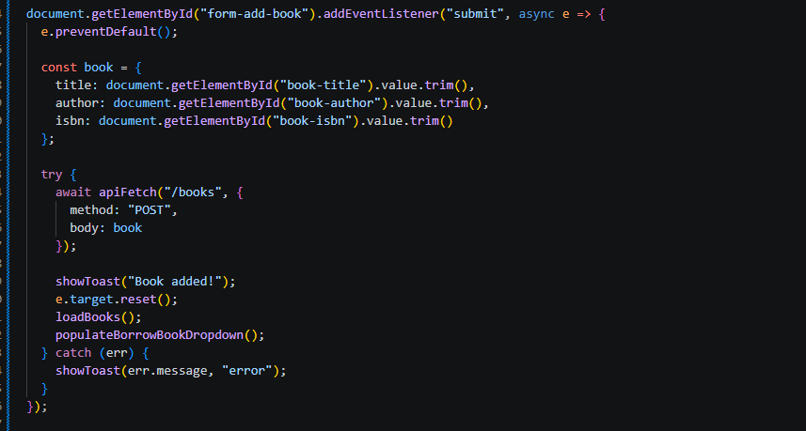

Part-08-loadmembers SCREENSHOT 8
Code
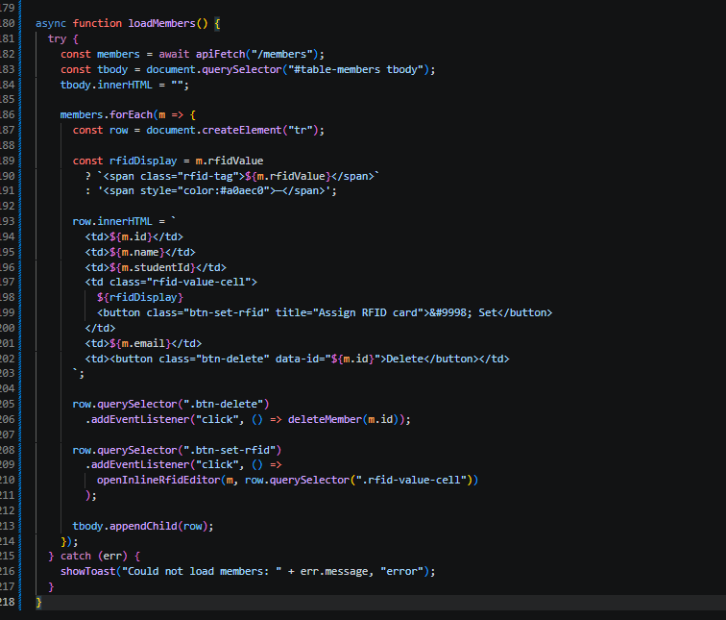

Part-09-deletemember SCREENSHOT 9
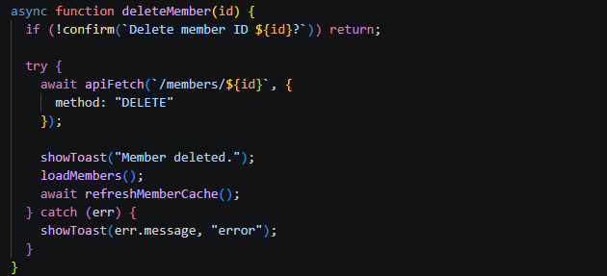

Part-10-addmember SCREENSHOT 10
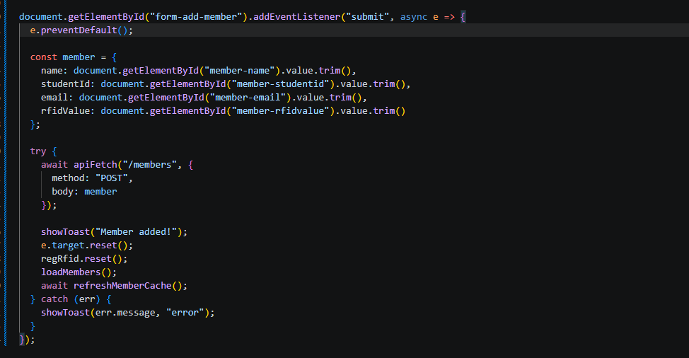

Part-11-inline-rfid-editor SCREENSHOT 11
Code
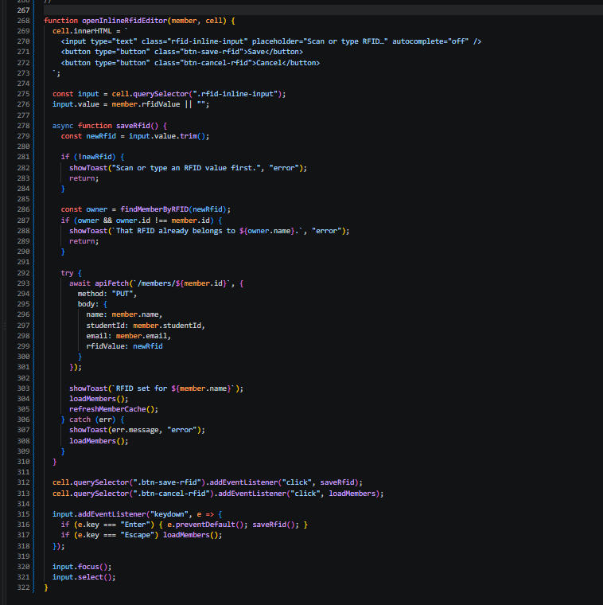

Part-12a-rfid-widget-builder SCREENSHOT 12
Code: createRfidWidget()
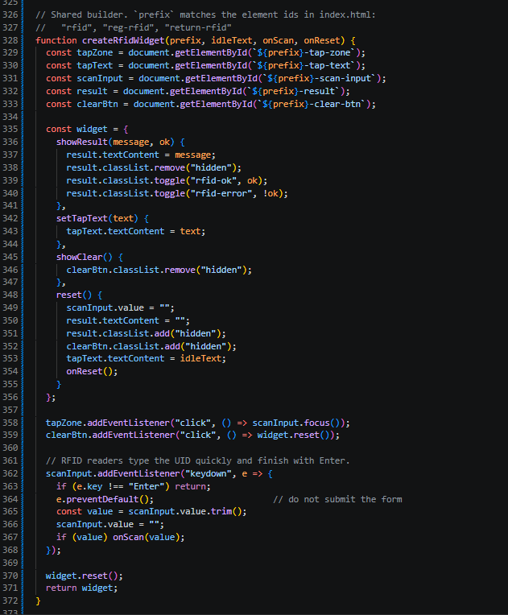

Code: initRFID()
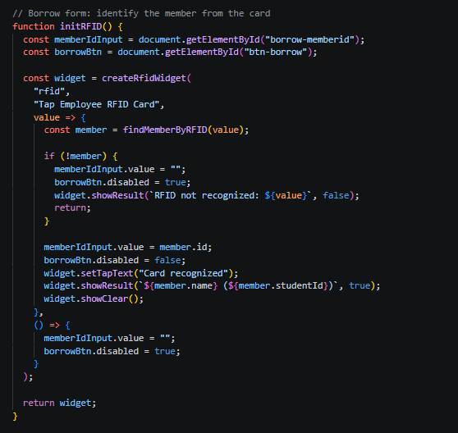

initRegRFID()
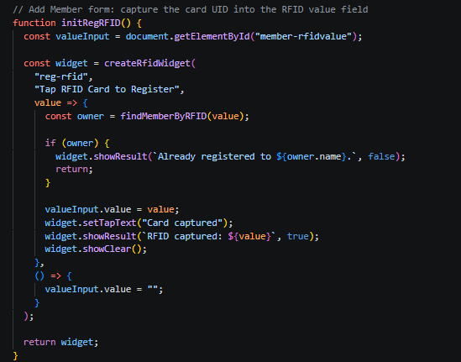

initReturnRFID()
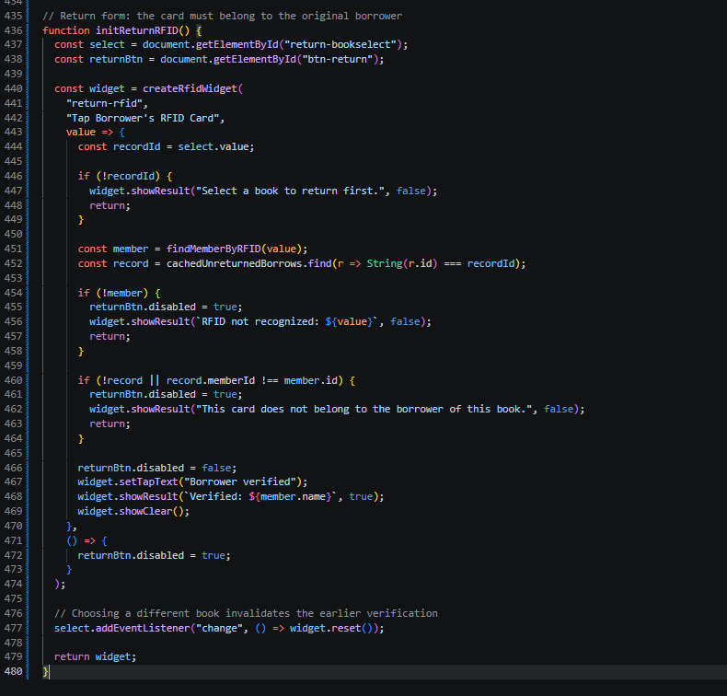

Part-13-borrow-dropdown SCREENSHOT 13
Code
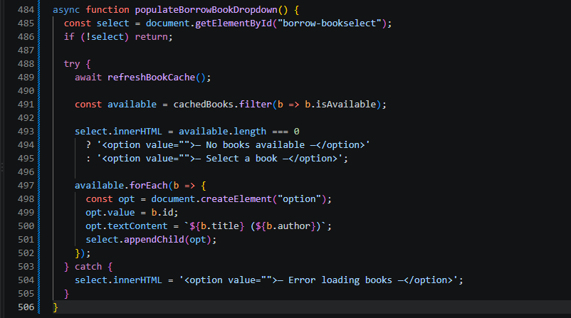

Part-14-return-dropdown SCREENSHOT 14
code
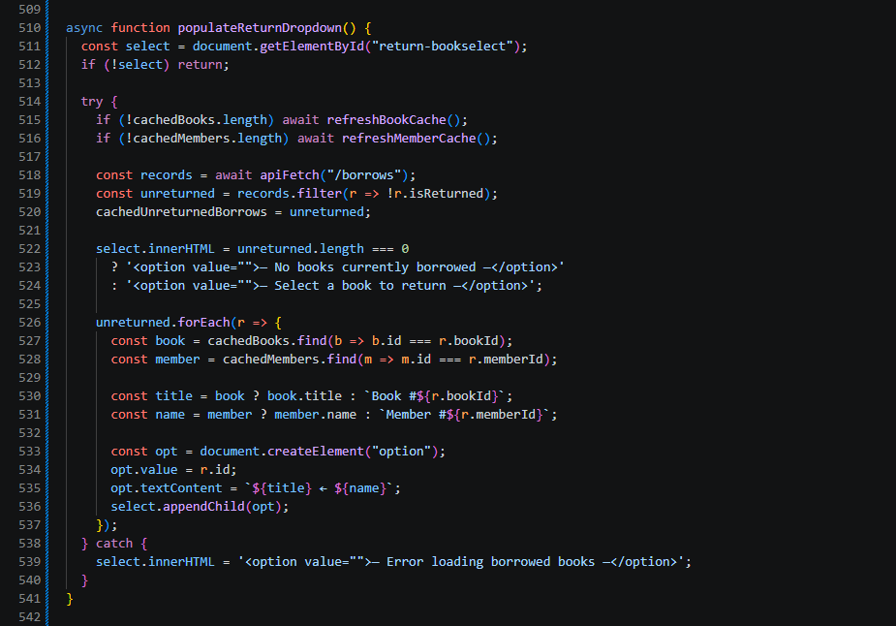

Part-15-borrow SCREENSHOT 15
code
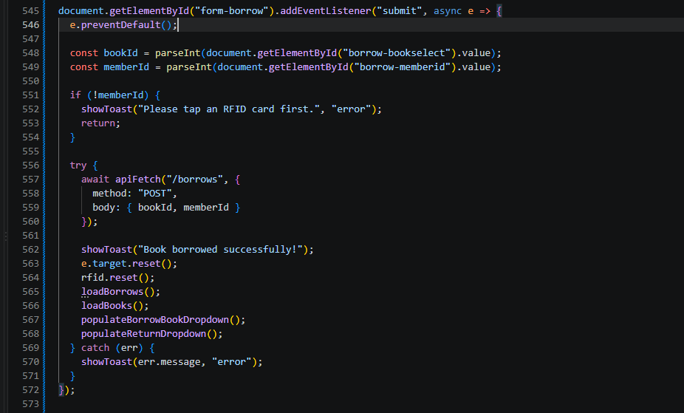

Part-16-return SCREENSHOT 16
code
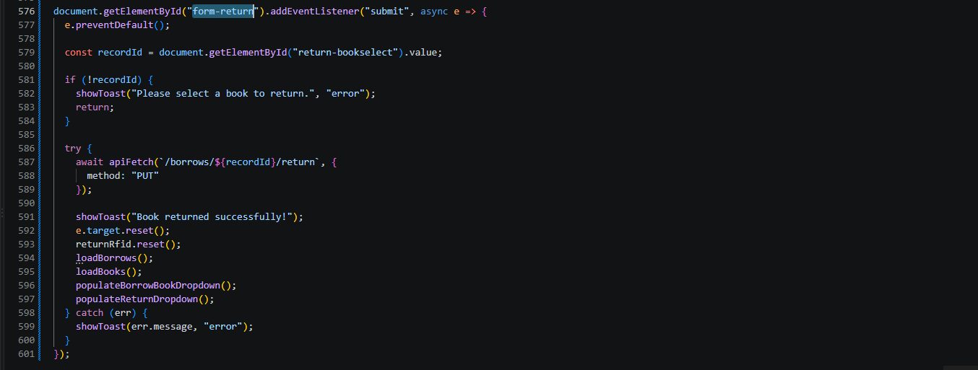

Part-17-loadborrows SCREENSHOT 17
Code
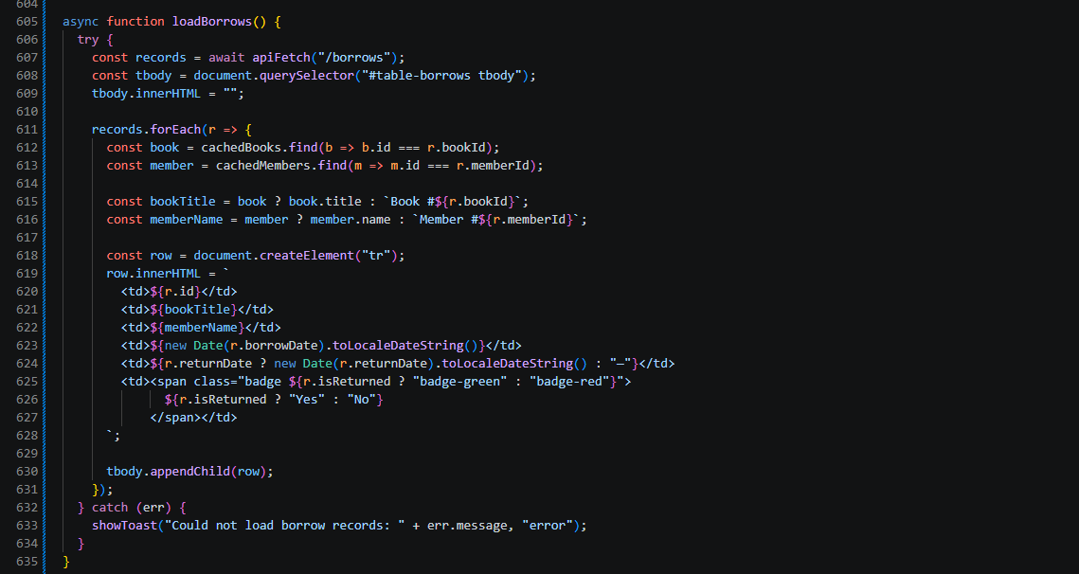

Part-18-page-load SCREENSHOT 18
Code:
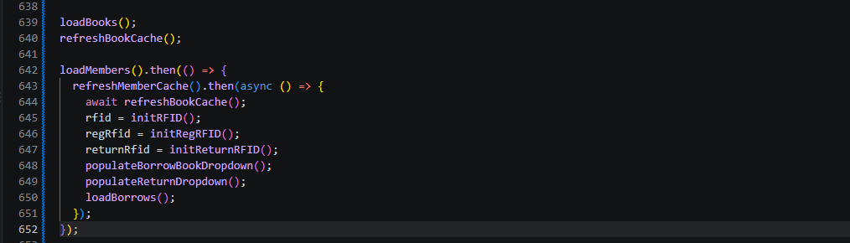

Test-01-page-loaded TESTING 1
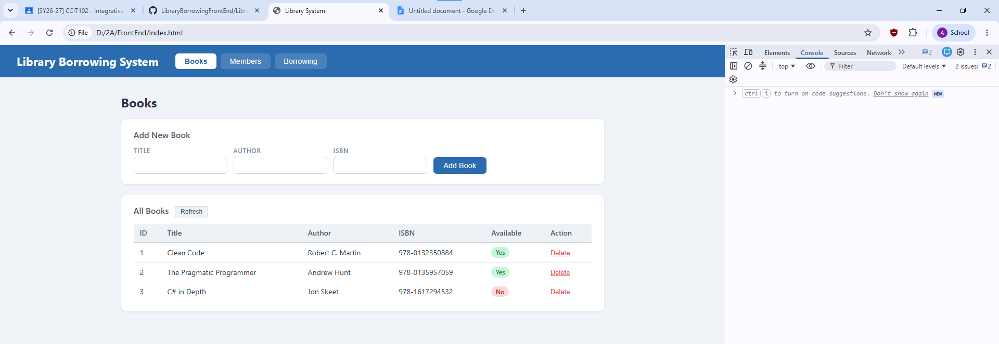

Test-02-add-book TESTING 2
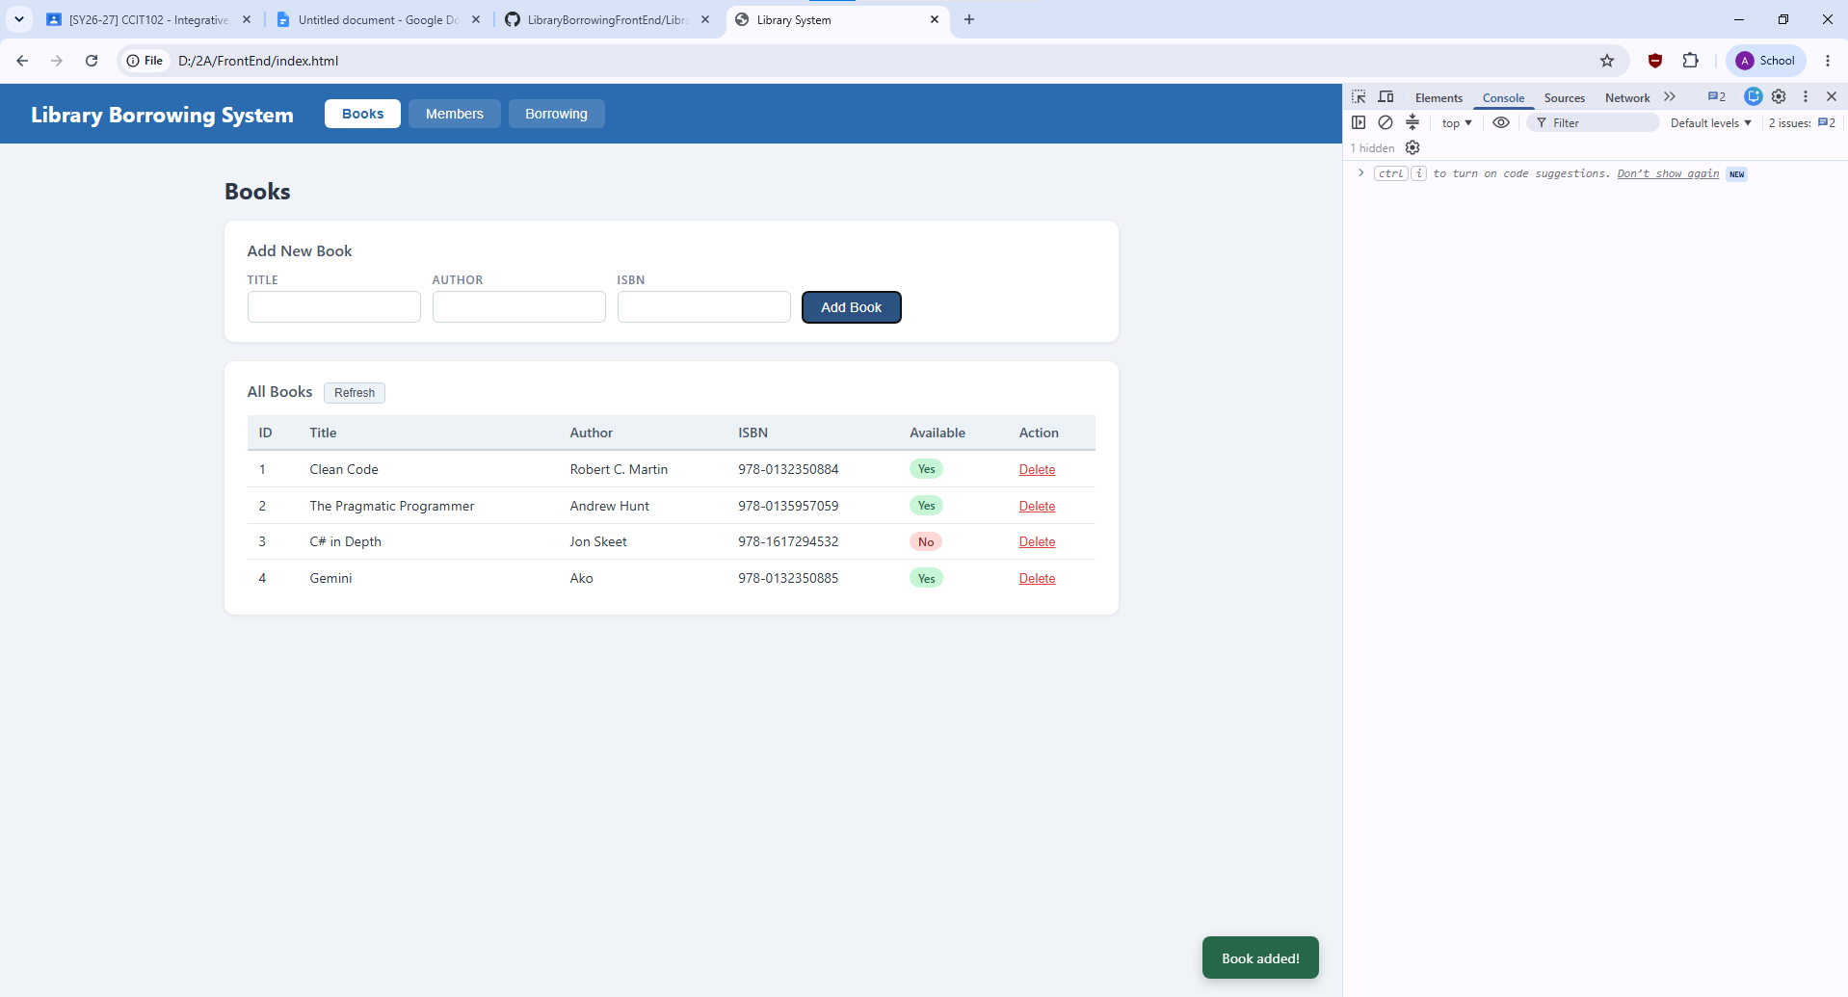

Test-03-delete-book TESTING 3
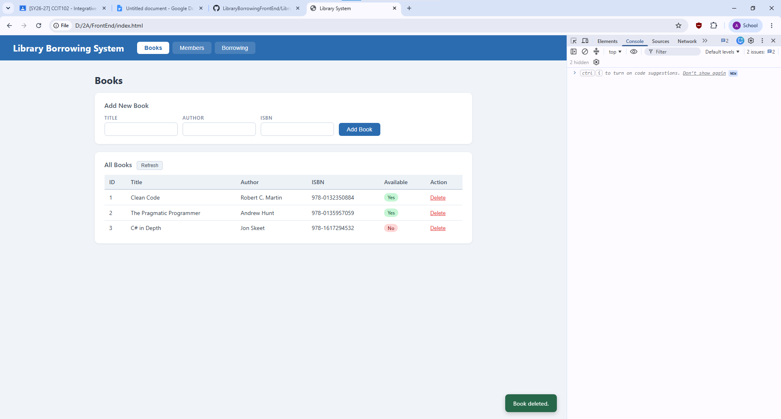

Test-04-members-loaded TESTING 4
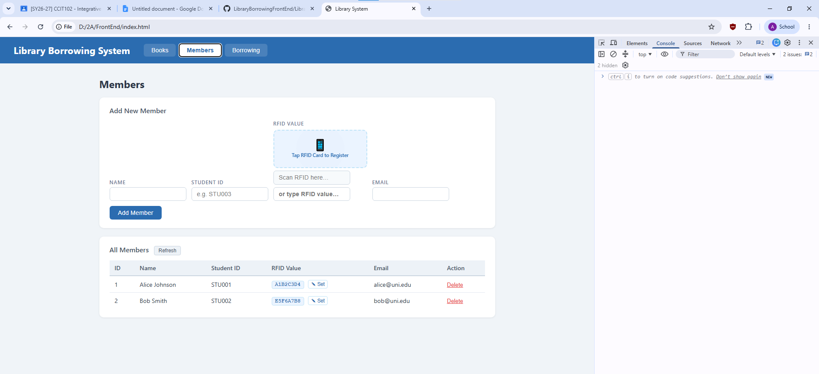

Test-05-register-rfid TESTING 5
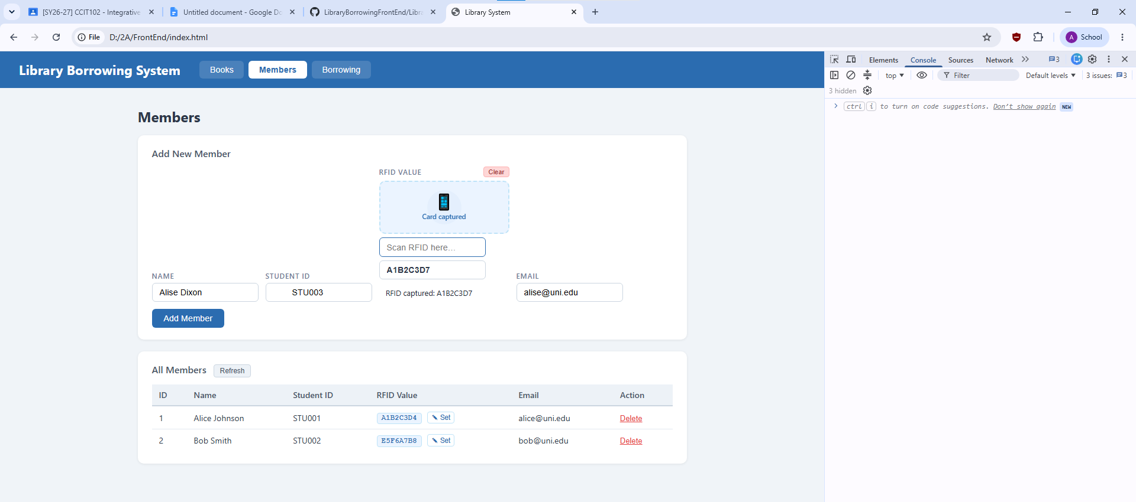

Test-06-add-member TESTING 6
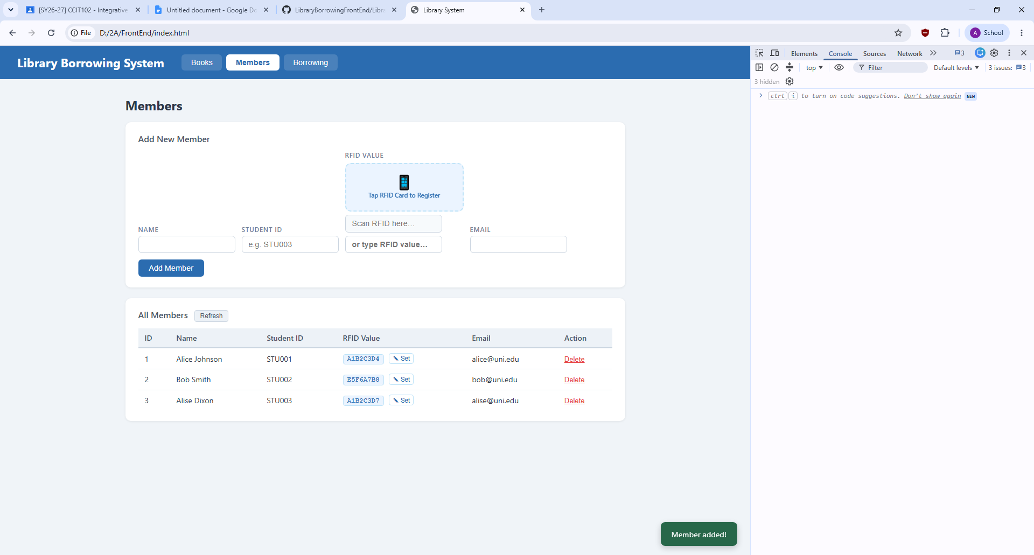

Test-07-set-rfid-saved TESTING 7
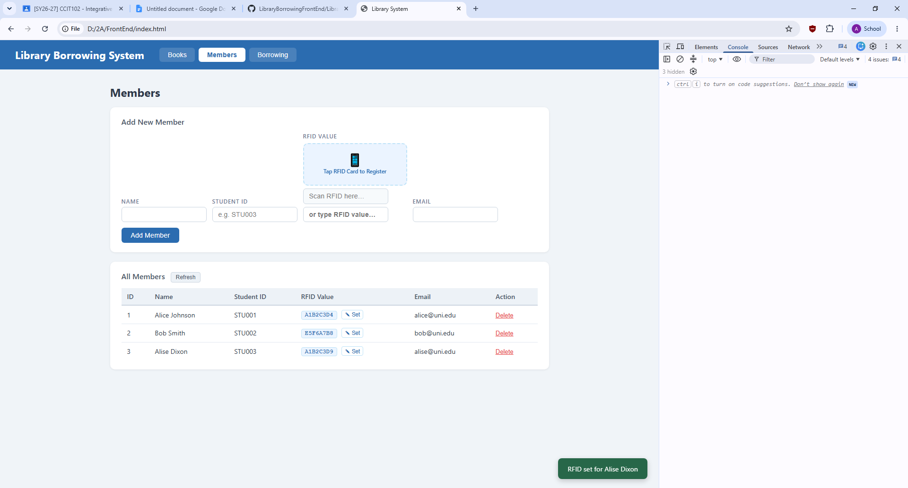

Test-08-delete-member TESTING 8
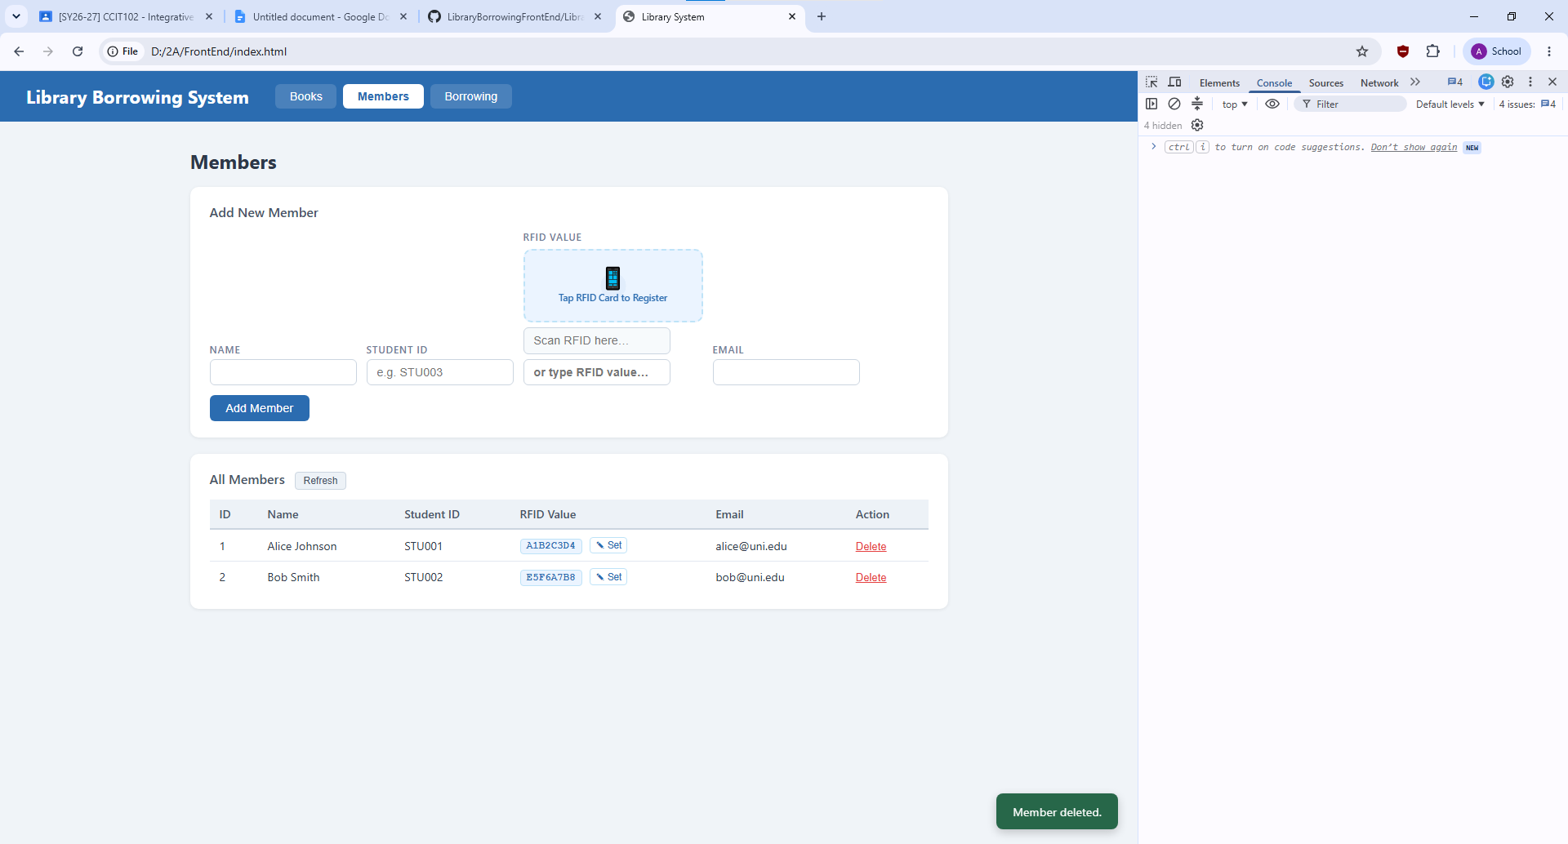

Test-09-borrow-rfid-recognized TESTING 9
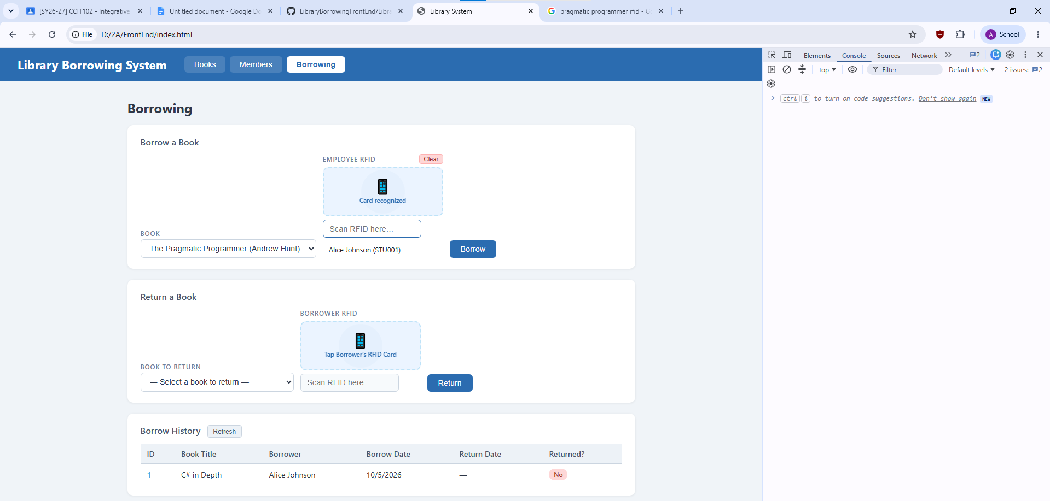

Test-10-borrow-success TESTING 10
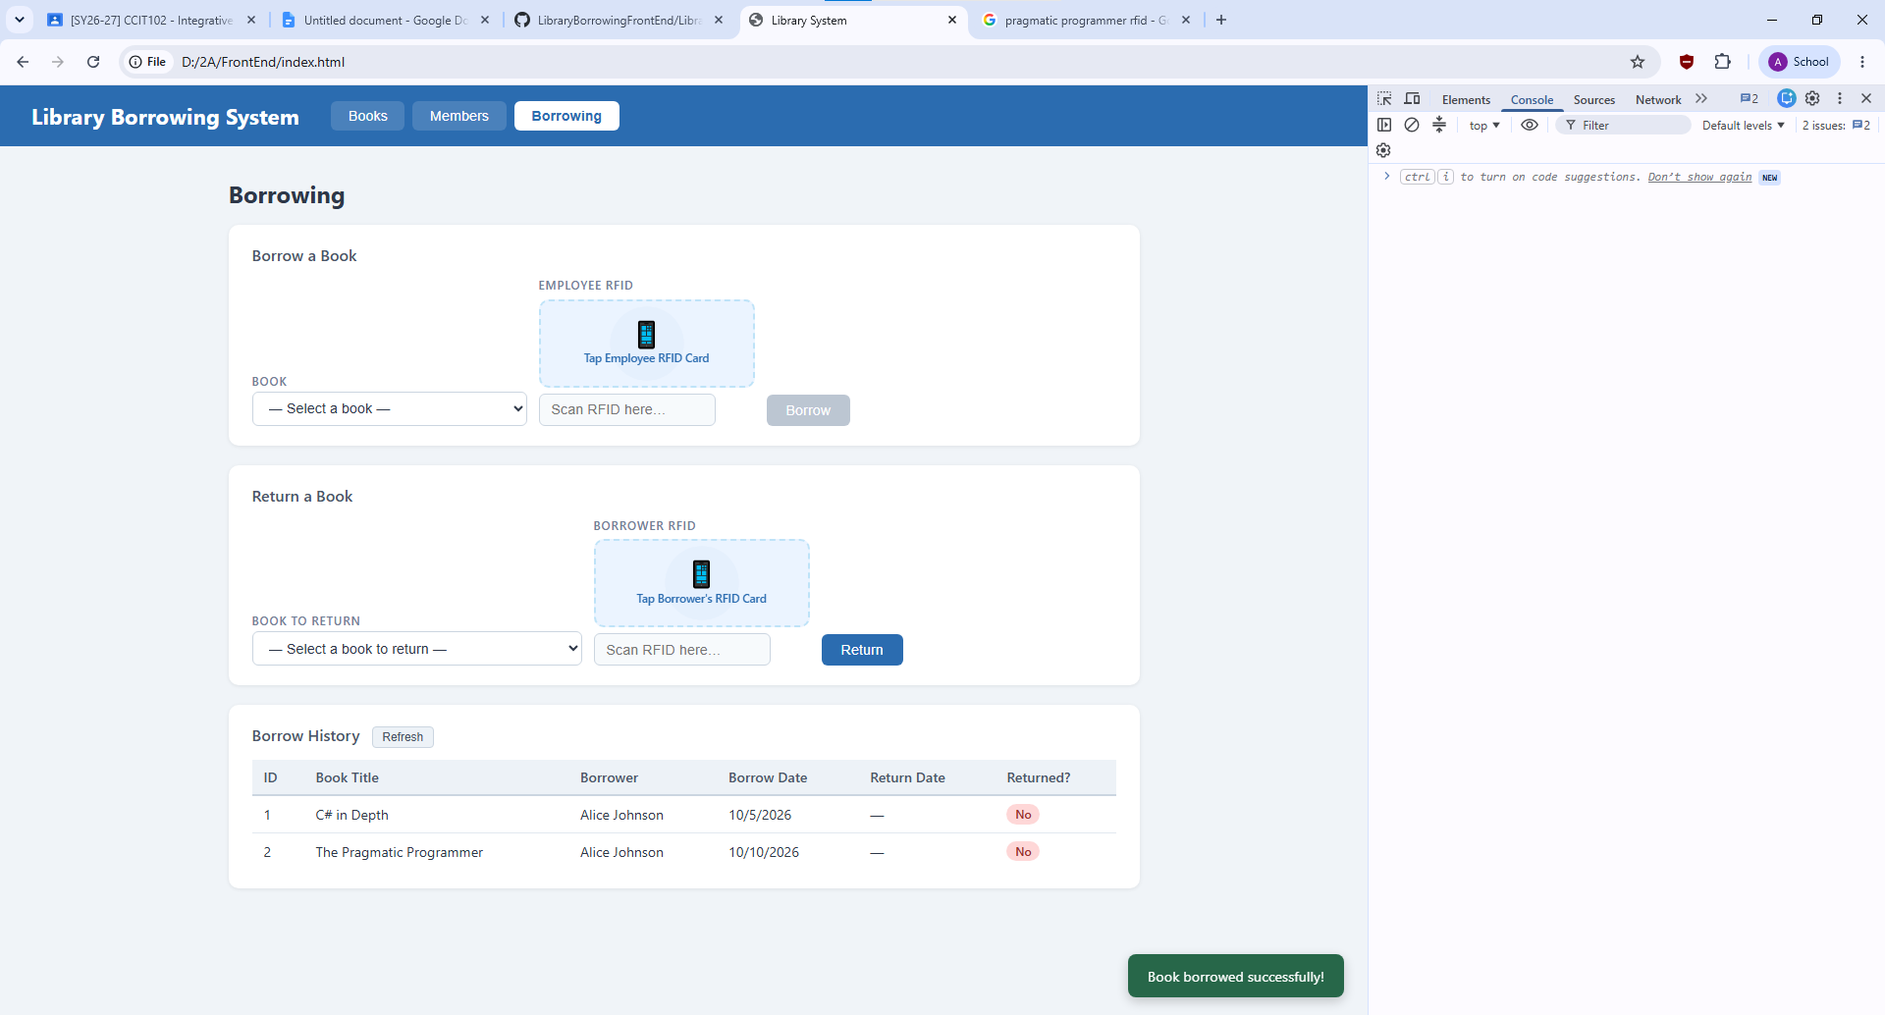

Test-11-return-wrong-card TESTING 11
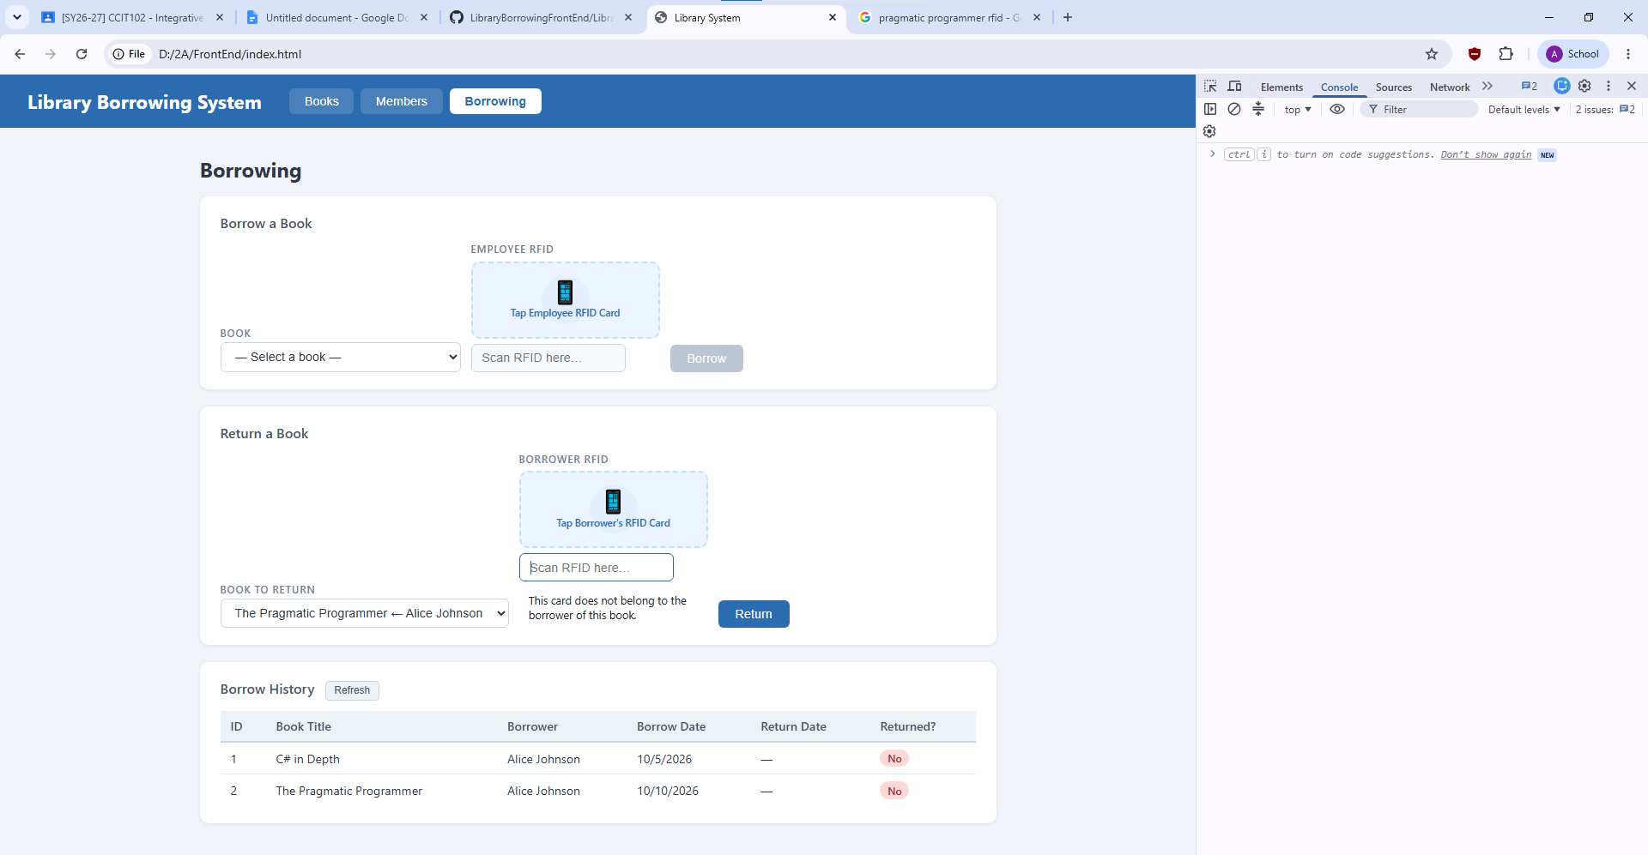

Test-12-return-verified TESTING 12
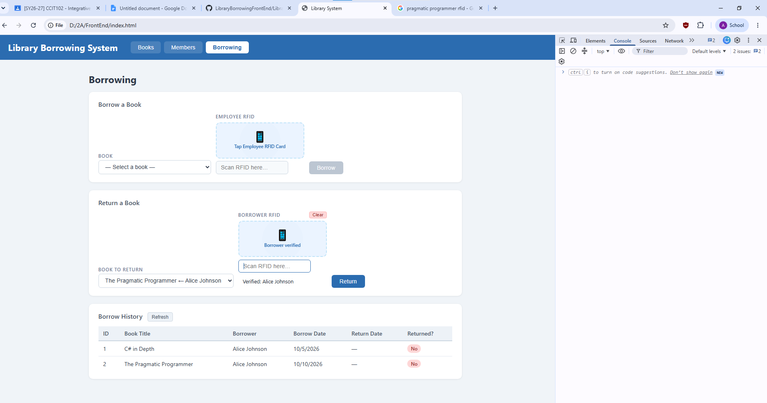

Test-13-return-success TESTING 13
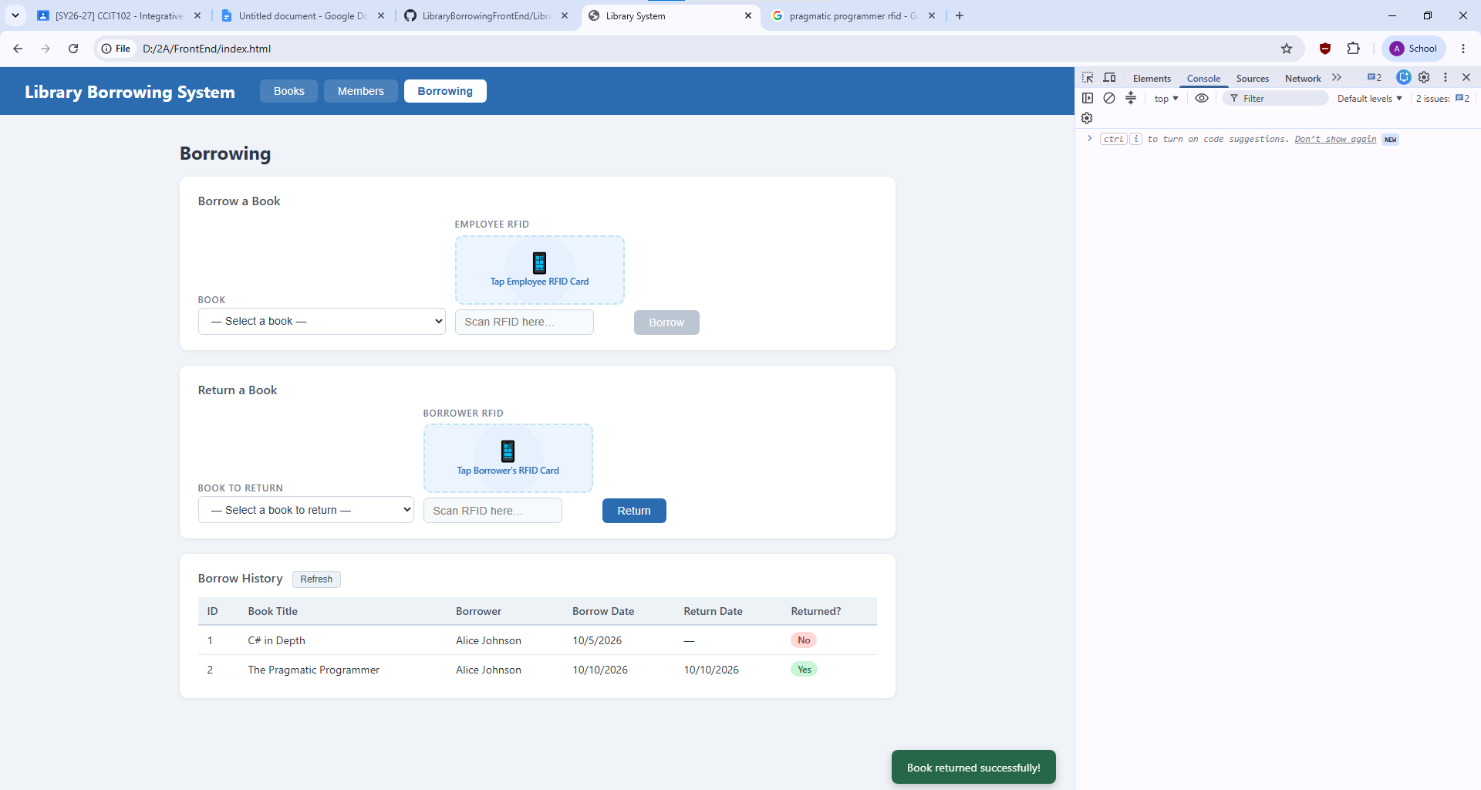

Test-14-final-console TESTING 14
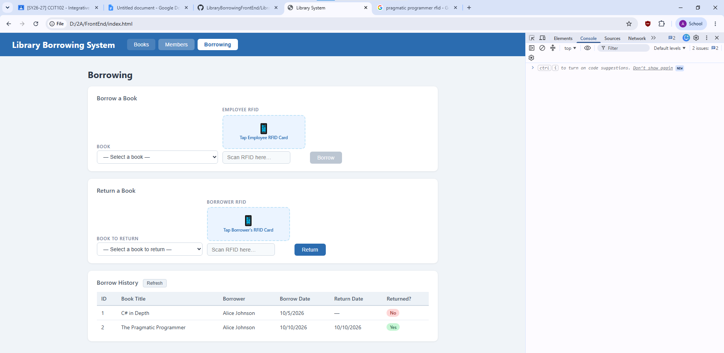

Reflection
- What does apiFetch() do?
- prevents repeated code. Instead of a long fetch() call every time, you write apiFetch("/books").
- Why do we use try/catch around API calls?
- We use try/catch blocks around API calls primarily to prevent application crashes, handle unpredictable network failures, and improve the user experience
- What is the difference between POST and PUT?
- Post is to add data while, Put is meant to update the data.
- Why does RFID matching use rfidValue instead of studentId?
- For it to work in the application because it cannot match with the studentId.
- Why do we refresh tables after adding, deleting, borrowing, or returning?
- To ensure the user interface accurately reflects the data without crashing.
- Why does the Return dropdown use borrow record ID instead of book ID?
- So that when we return it will reflect to the borrowers ID instead, because relying on the book ID will not lead to the actual borrower.
- What happens if the same event listener is added to a form twice?
- It sends 2 request in one click, instead of one only.
- Why must the page-load code be at the bottom of the file?
- To make sure that all the codes before it will run due to how compiler works reading it from top to bottom. Also, the order matters in this program, making sure every function will work rather than being suddenly reloaded.
- Why does an RFID reader need e.preventDefault() on the Enter key?
- So the form is not submitted by accident.

